I decided to re-do the Seq FAQ to make it a bit more user friendly. Plus add more pictures.
I think everyone needs to get a grip first on how the system should operate in good condition. Without understanding this then you can get confused as to where to start. I was aided by Cameron Neil of Ishii Motors to help with some of the actual “hands-on” help. As he has repaired many “ill” Supra’s over the years.

How the Sequential system works.

There are 5 main control components for a working sequential system. They are the Wastegate for overall boost control, Intake Contro (IACV)l, Exhaust Control (EGCV), Exhaust Bypass Control (EBV), and the Pressure Tank (PT)

Picture A
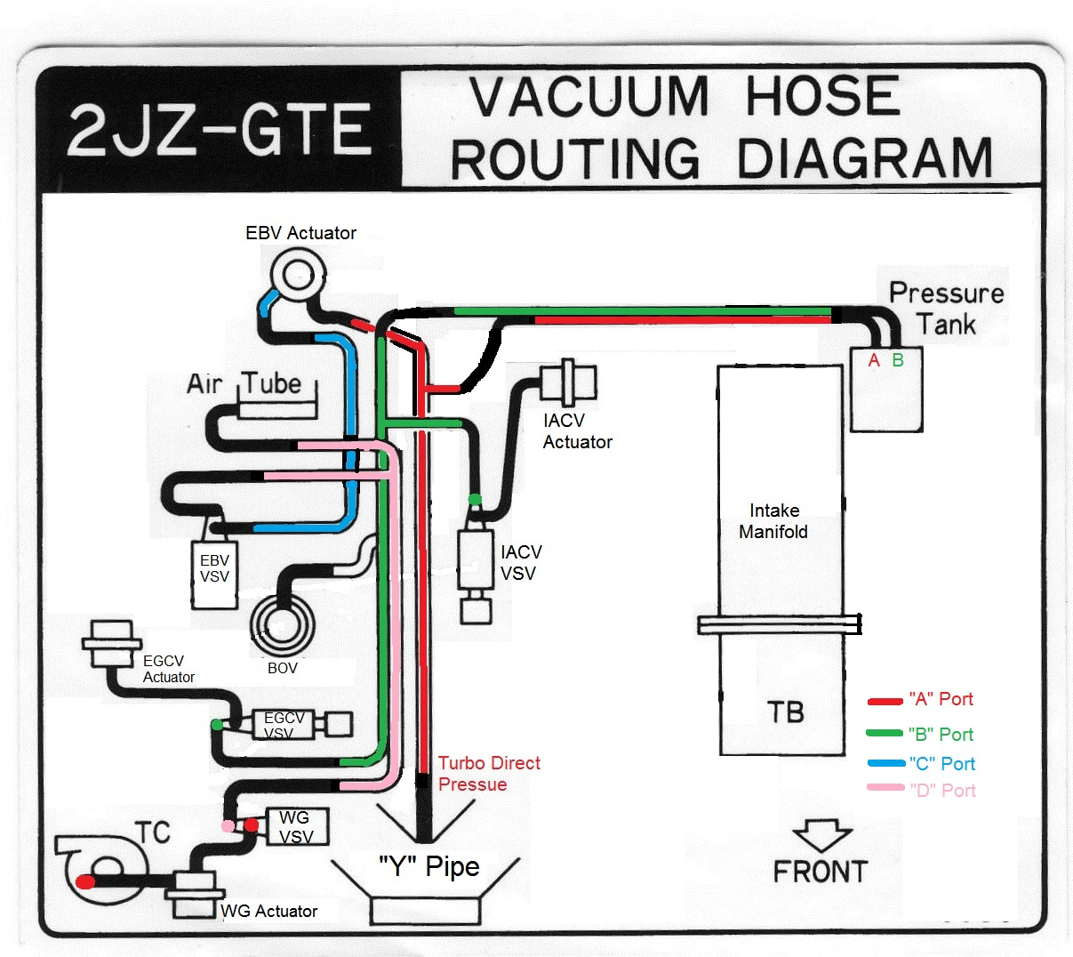
“A”-Port Pressure side-feeds. “B” Port Pressure output to VSVs. “C” Port EBV VSV vent. “D” WG Venting

Within these 5 controls, 4 operate using VSV’s (vacuum switching valves) and actuators. In Picture “A” the “hot” side in red is where the boost pressure comes. The “Y” pipe is the collection of the 2 turbo outputs off the compressors. This pressure feeds the pressure tank and the EBV rear actuator.

When positive pressure is developed, the Pressure Tank gets charged. At about 3800 rpms, the ECU sends a signal to the IACV and EGCV to open the valves via the 2 VSVs, This allows the pressure tank to send the charge of pressure to snap open the 2 actuators. Which are IACV for the charged compressed air and the EGCV to allow the rear #2 Turbine wheel to achieve full boost. Prior to this, the EBV opens linear to boost pressure and slowly opens the internal bypass flapper to start engaging the #2 to start up. So when the EGCV fully opens, it doesn’t blast the #2 turbine as it is now up to speed.

Picture “B” is another layout color coded of all of the important parts of the Seq. System

Picture B
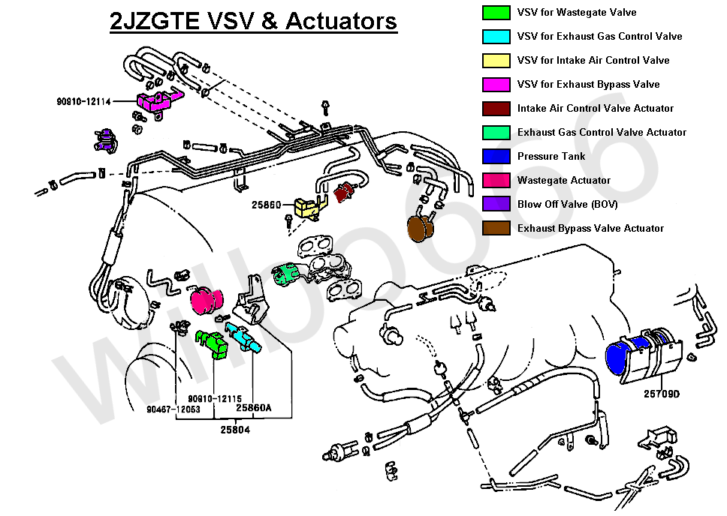

Picture “C” are the 4 main components for the valves. Each one has a specific “crack” pressure. So when testing these with a Mityvac, they will start to open at the designated pressures.

Picture C

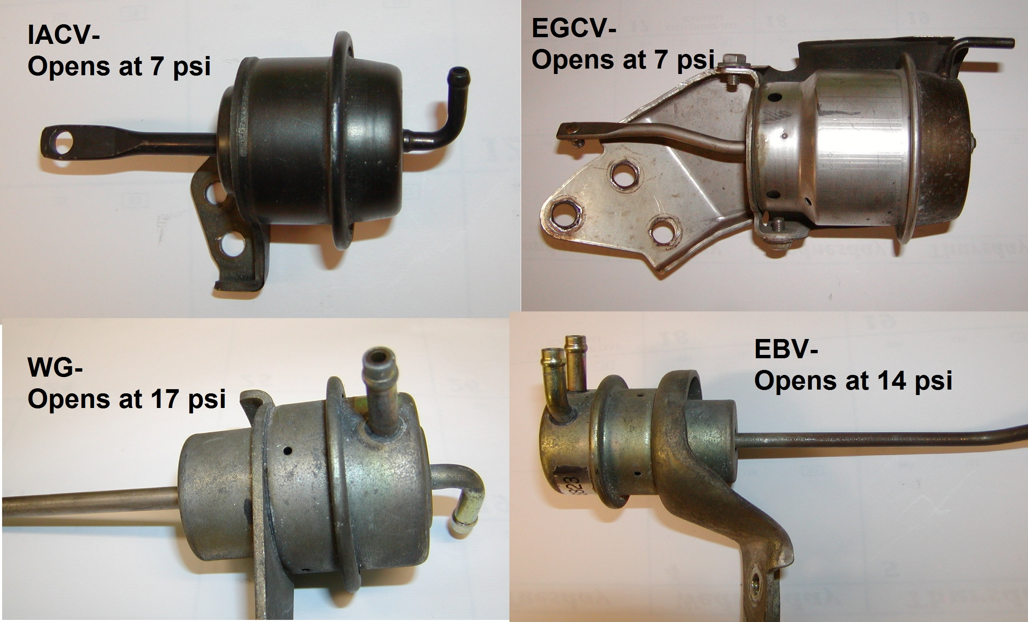

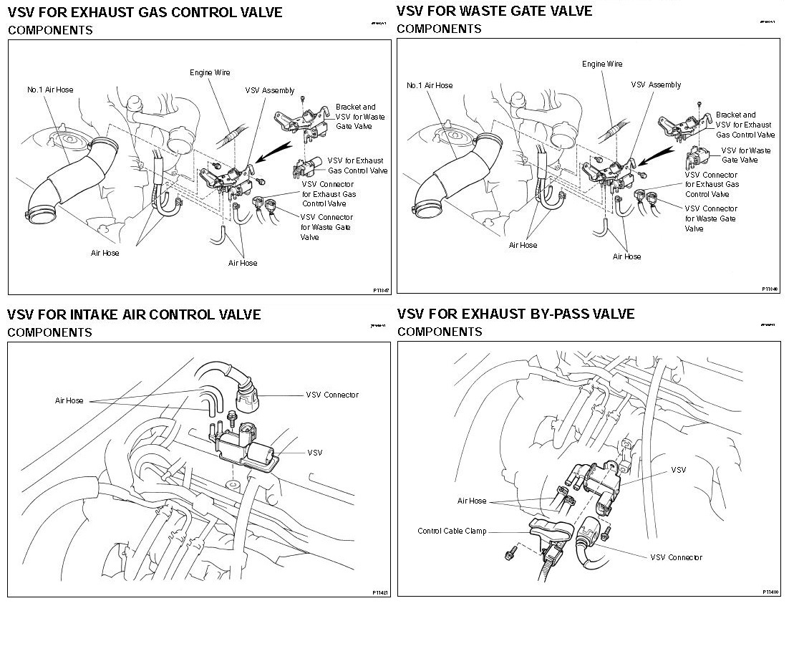
Picture “D” above are the 4 main VSVs

The IACV and EGCV are the 2 main VSVs that control the transition to full boost at about 4K RPMS. Without both of these functioning properly, your car will NEVER see more than 10.8 Psi, even if you have the ability to go to 24psi. The EGCV basically closes off the #2 from spinning, and the IACV closes off the charged air. If either one valve isn’t functioning and does not open, then you will never see more than 10.8Psi. Other words, you’re running on the #1 turbo only from 1000-7000rpms if these don’t open. Imagine trying to blow into a straw with your finger plugging the other end.

Both these Valves open within 100 rpms of each other at 3800 rpms. No sooner, and no later, There is NO other ECM input for this; RPM dependant only. What does vary is how long it takes for the transition. A faulty actuator, damaged vacuum hose; faulty VSV, altitude, and temperature are some of the leading factors for a longer than normal transition time.

A healthy system will start to see boost about 2000rpms under moderate load and 3rd gear or higher. By about 3000 rpms the boost will stabilize at about 10psi, (.7bar) and HOLD until transition starts around 3800 rpms. By 4000 rpms you should be seeing elevated boost. If totally stock you should reach full 11psi at 4200rpms. If you are using a BC and have it set for greater (16psi+) then full boost might be around mid 4K range.

Starting the testing processes

STEP-1:
Pull off vac hose as noted in “A” below (It may break-so replace) Using the Mityvac, connect the mityvac hose to the metal loom port where the red line is. Then pressurize to 20psi if you can for 60 seconds. If you cannot, proceed to STEP- 2.

If successful go to STEP-4

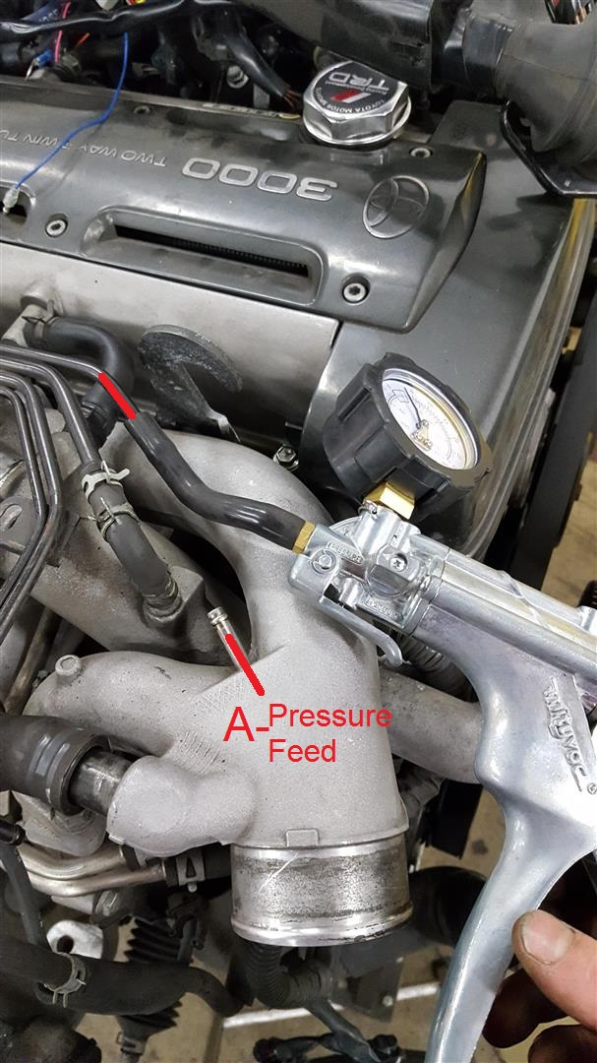

STEP-2: Referring to top picture, cap off metal loom Ports “B” (Green) and “C” (Blue)

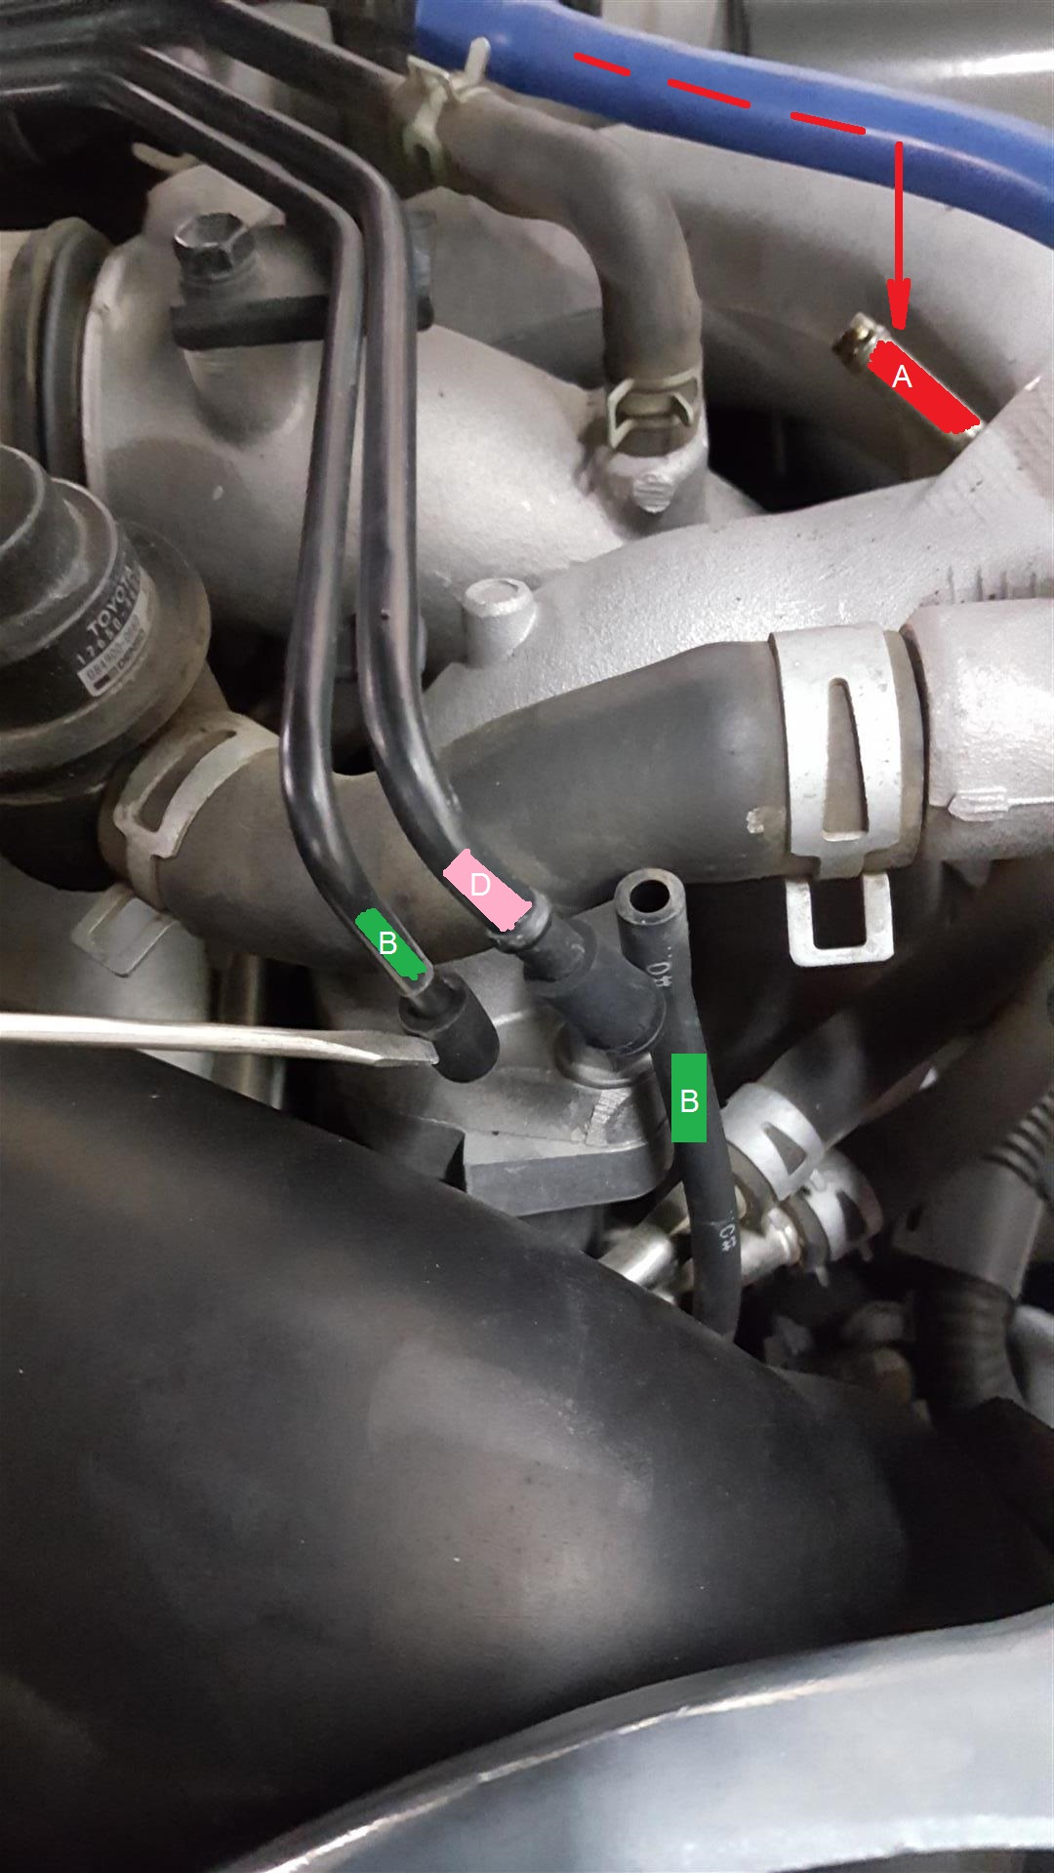

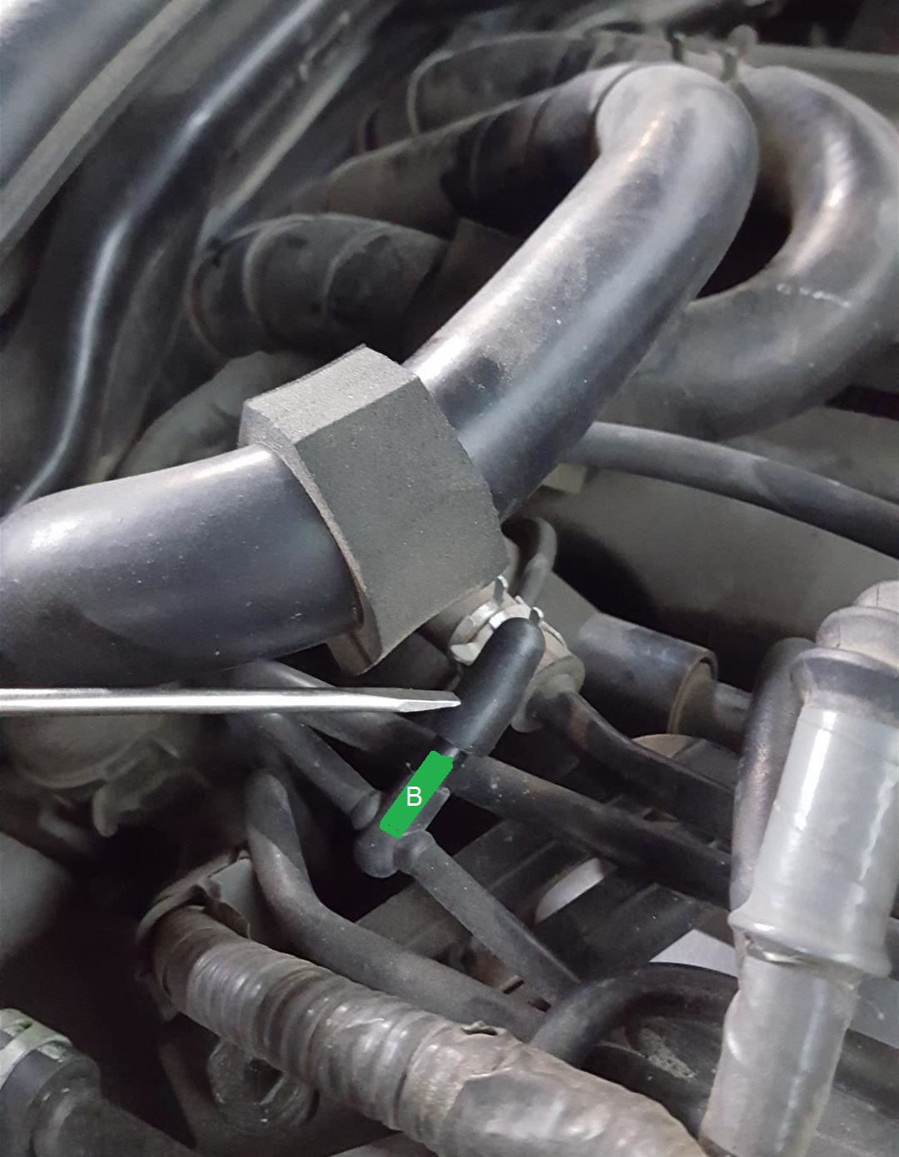

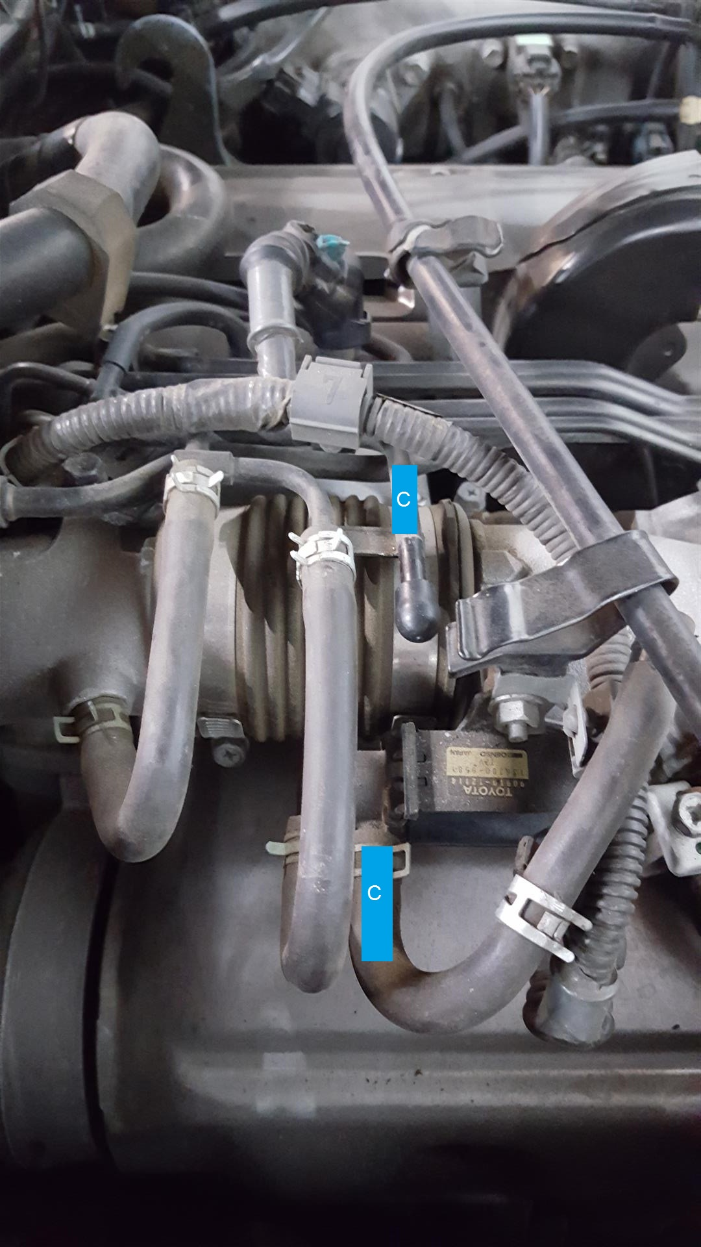

Now pressurize the front “A” port to see if you can get to 20psi. See how long it holds at 20psi as it should stay steady for a minimum of 60 seconds. Some drop off is OK but not below 18psi.

If you cannot hold this pressure go to STEP-3

If this is successful then we now know that the Pressure Tank is OK and the Vacuum hoses are holding pressure. ALSO, you will then see the rear EBV Actuator rod has fully extended.

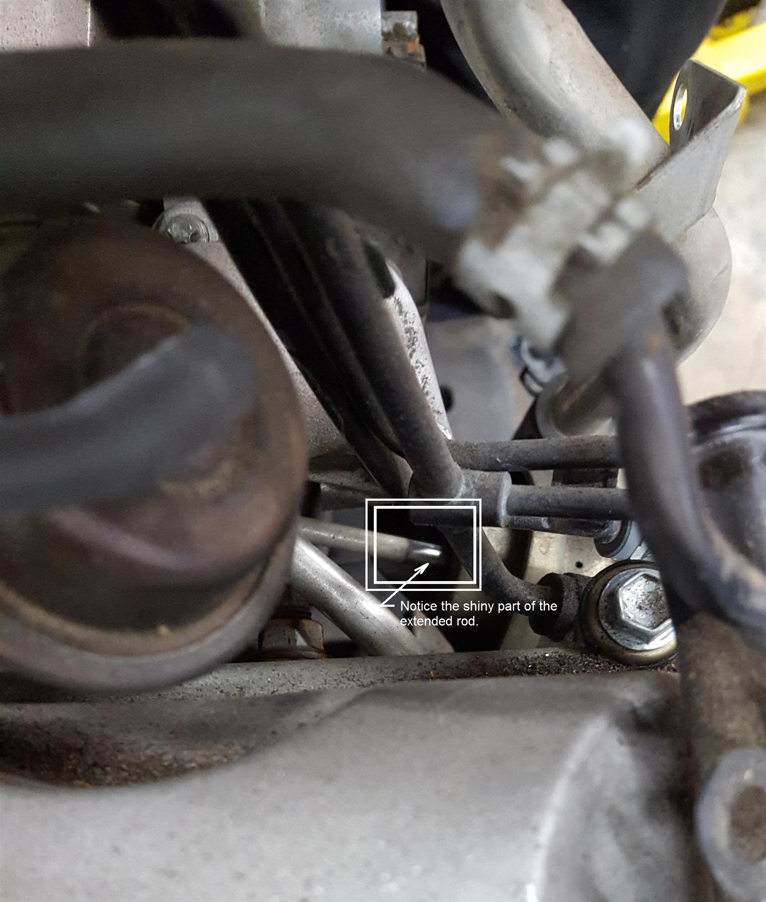

Keeping an eye on the extended EBV Actuator rod, release the pressure by removing Mityvac hose at pressure port “A”. They Actuator rod should snap shut.

Then go to Vacuum hose (Green Port-B) at the IACV VSV and listen for the release of pressurized air from the Pressure tank.

STEP-3

A healthy system will hold pressure in the pressure tank for quite a bit of time. If you do not get a release of pressure then the PT is bad, or the hoses going to it or from it have failed. Getting to the PT is a bit hard, and getting to the hoses is impossible, as they are behind the engine and go along the firewall.

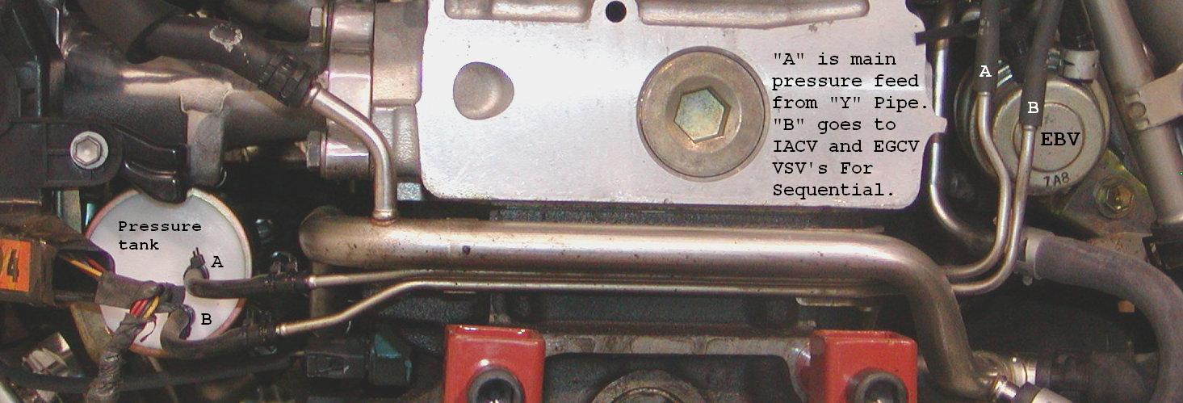

The below is a close up of the above right side showing the rear of the EBV Actuator and Pressure tank “IN” and “OUT” Hoses (Left 2 hoses). You can access these but it requires removing pretty much of all the piping and metal loom and IACV from the rear turbo compressor outlet. If any of these hose are damaged/cracked/broken, you will NOT get and pressure to hold in the Pressure tank nor ne able to extend the EBV actuator rod.
To access the pressure tank you can reach up and feel with your hand the hoses if the car is on a lift. Feel lucky if you find that the “A” hose just blew off and you can re-install and zip tie. This most likely will solve all of the issues.

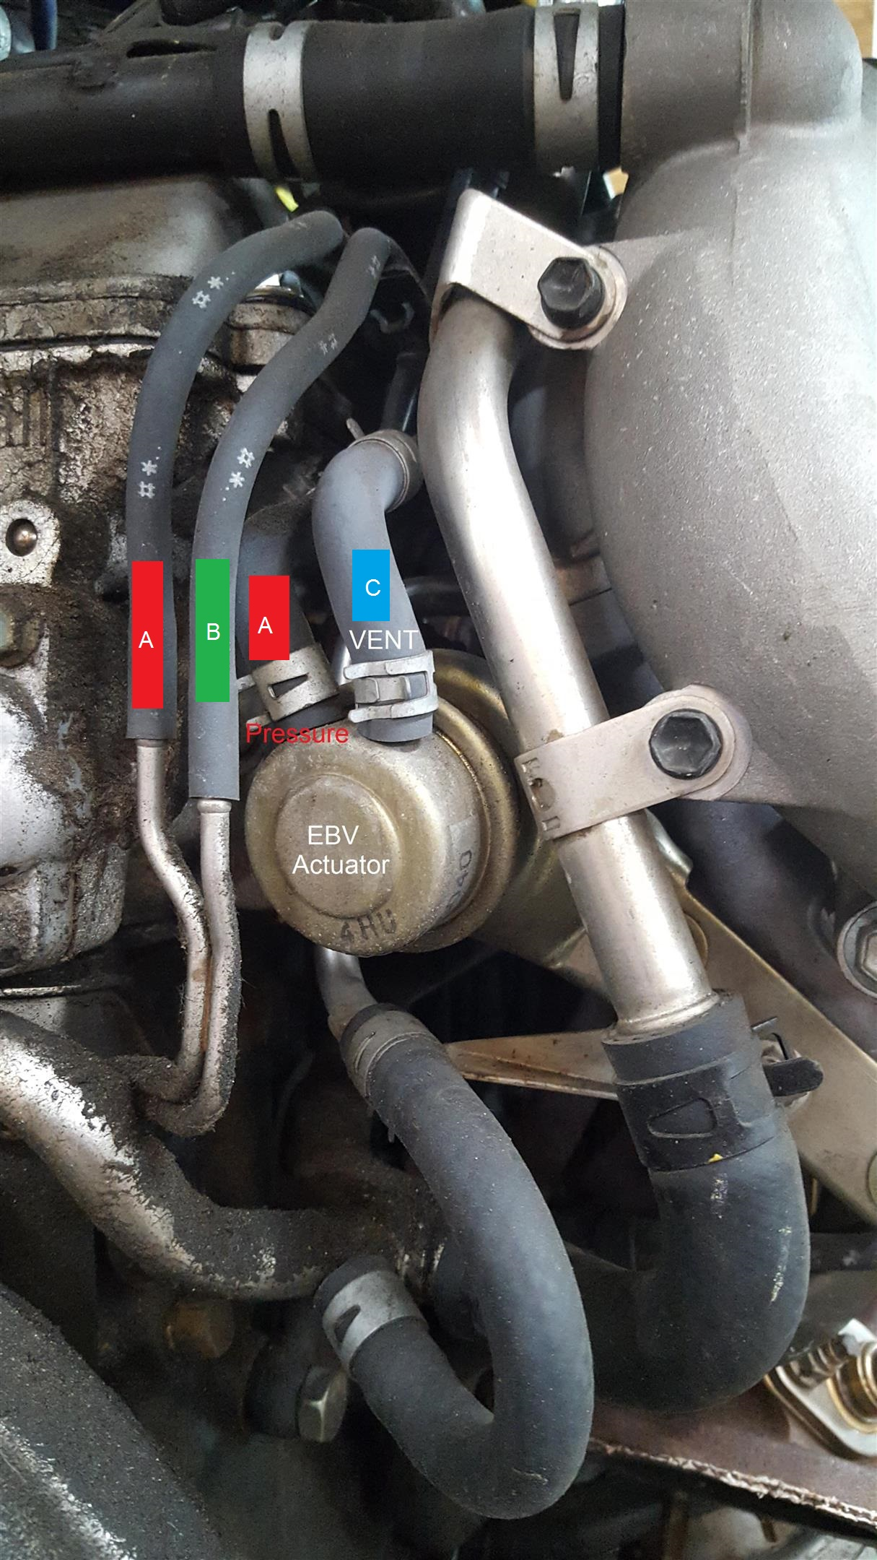

STEP-4

Check VSVs for pressure drop and continuity.

Testing all the VSVs is relatively the same. You plug one side and pressurize the other. There should be ‘0’ pressure loss when testing.

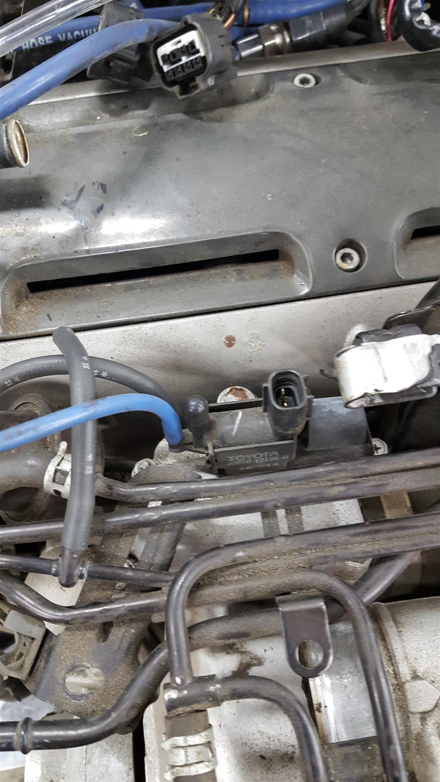
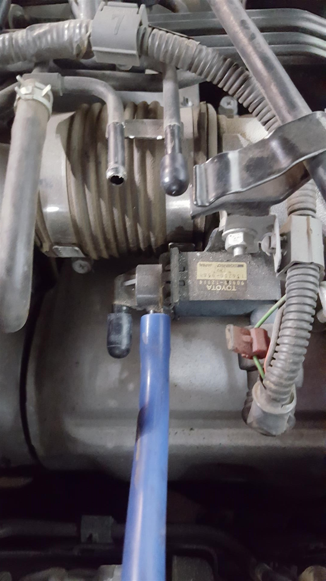
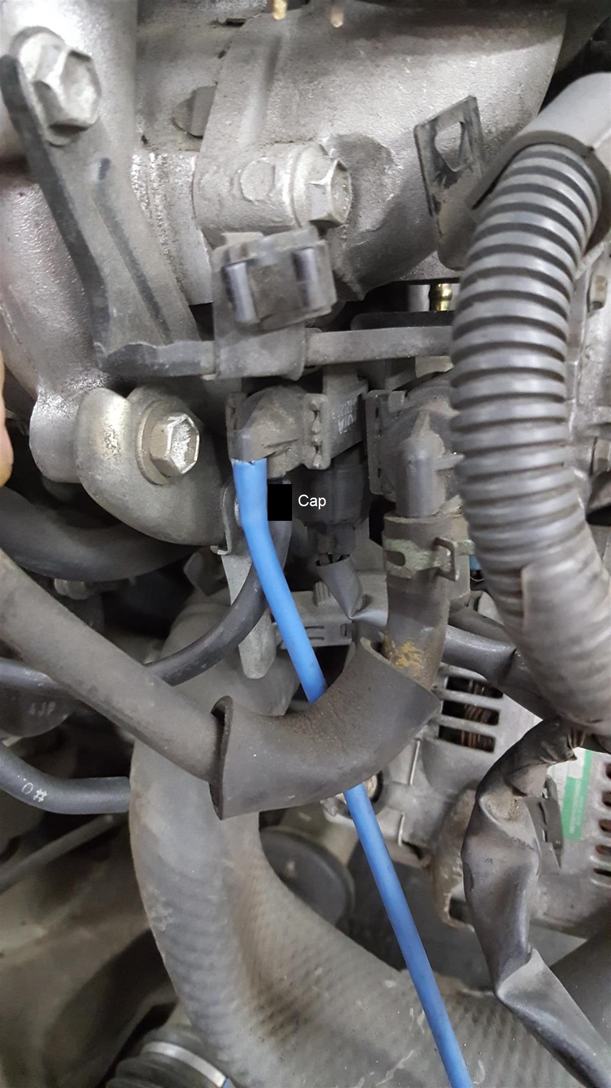

Each of the VSVs have resistance testing ranges….testing is really the same procedure for all.
Testing about ambient 69 degrees F

IACV-38.5 TO 44.5 OHMS
EGCV-38.5 TO 44.5 OHMS
EBV-22.0 TO 26.0 OHMS
WG-22.0 TO 26.0 OHMS

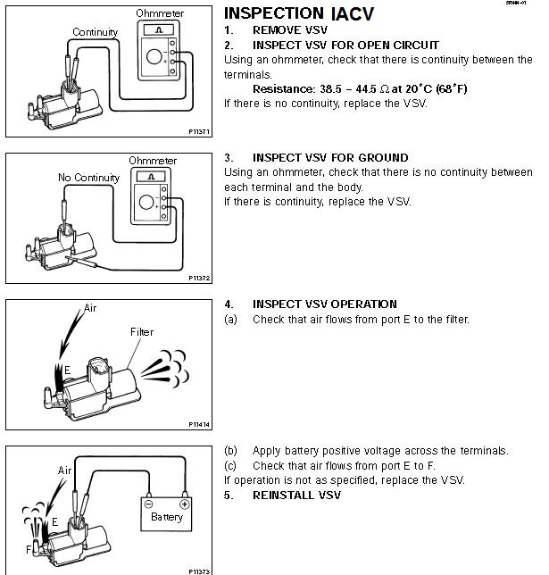

Now, If the car still runs like crap, then it can be one or all of the following.

1) Requires the removal of a lot of stuff to inspect the compressor blades. So let’s save that for last!

It is somewhat common that the rotating ARM circled below that goes to the EGCV internal ceramic flapper is busted and you cannot tell as it appears to be rotating but the flapper is not.

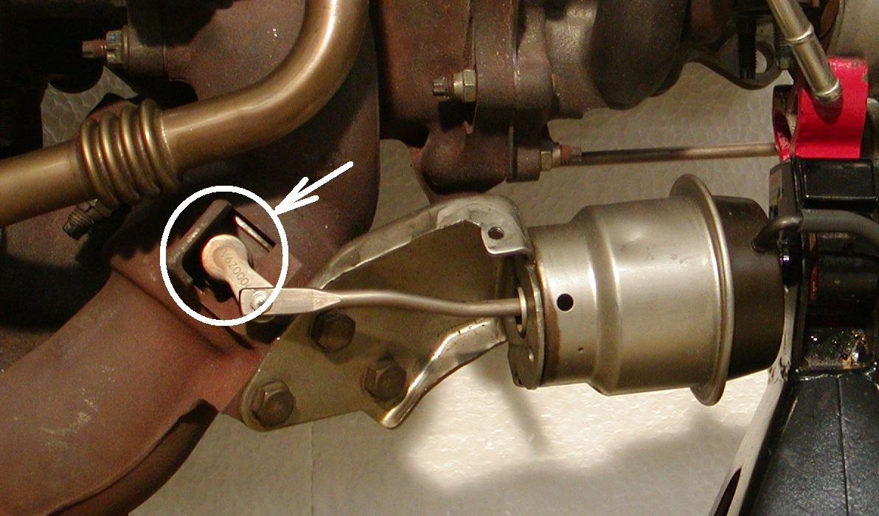

Sadly. Only way to tell for sure is to the remove the DP and pressurize the EGCV and make sure the internal flapper is rotating or not. Alternately, if it is indeed busted, poke up into the flapper and if it moves by poking it has busted and this is why you’re not getting past 7-10psi

When it comes to the sequential operation, these tests should find the issues. Assuming the #2 turbo is good. There isn’t any other thing that could cause no post transition boost increase. I have heard that a bad WG VSV can cause an issue, but checking the continuity should see if it is bad or not.

If now you finally get post transition boost, greater than pre-transition boost you have solved the issue. But there are other issues that can cause “poor” boosting, or sluggish boosting. Like a bad reed valve, collapsed corrugated couplers, sticky actuator arms, or intermittent VSVs.

There are Two tests that can give you an idea of your systems potential. One, remove the hose off the front WG actuator and go for a spin. Be a bit careful as this removes all boost control and will give you whatever your system can. Or the same as a EBC at 100%.

2nd test is to remove the inward vac hose on the EBV VSV. This will give you the maximum pre-transition boost your car is capable of. Again, be careful and let off before 3500rpms and do get into transition. I have seen cars get over 20psi at 3500rpms as this removes the EBV safety net.

If you get positive results then you can rule out the below possibilities

1) bad #2 turbo,
2) Bad or defective pressure tank,
3) Broken EGCV ceramic arm
4) Collapsed rubber turbo pipe coupler,
5) Defective reed valve.

If you get negative results then it could be a bad turbo. But fixing any of the above 5 areas should result in a repaired functional Sequential operation.

